Wind Tunnel Lab Report

TU23FL Fluids Lab

Sec.3 Gr.4

Jakob Werle

Contents

Introduction 2

Apparatus 2

Procedure 3

Theory 3

Data Analysis 5

Discussion 11

References 12

Appendix 12

List of Figures

Figure 1 2

Figure 2 3

Figure 3: Pressure Distribution at 0 Deg 5

Figure 4: Pressure Distribution at 2 Deg 5

Figure 5: Pressure Distribution at 4 Deg 6

Figure 6: Pressure Distribution at 6 Deg 6

Figure 7: Pressure Distribution at 8 Deg 7

Figure 8: Pressure Distribution at 10 Deg 7

Figure 9: Pressure Distribution at 12 Deg 8

Figure 10: Pressure Distribution at 14 Deg 8

Figure 11: Pressure Distribution at 16 Deg 9

Figure 12: Pressure Distribution at 18 Deg 9

Figure 13: Pressure Distribution at 20 Deg 10

Figure 14: Plot of Lift & Drag Coefficients 10

Figure 15: Plot of Lift/Drag Ratio 10

Figure 16: Plot of Lift/Drag Coefficient for NACA 0012 Airfoil 11

# Introduction

The objective of this lab is to examine the behavior of flow over an airfoil and determine how air velocity and angle of attack effects lift and drag coefficients. An airfoil will be tested in a wind tunnel at various angles of attack and wind speeds. Using pressure readings along the air foil and recorded lift and drag forces, the coefficient of lift and drag will be theoretically calculated. This experiment has significant value in learning how airfoils operate and provide a foundation to apply fluids dynamics to a real application. Furthermore, the process of finding optimized angle of attack will lend itself useful in designing many things such as planes, vehicle body work, and fan blades.

# Apparatus

The apparatus used in this experiment is comprised of the a Plint Suction Tunnel, Plint three-component force balance, static pressure tube system, and an airfoil. The suction tunnel is the primary equipment that provides the airflow over the airfoil. Since this is a suction based wind tunnel, the airfoil is oriented so the leading edge is facing away from the suction fan. The angle of attack of the air foil is adjusted outside of the wind tunnel. Manometers are placed along the length of the airfoil and are read by the computer software. The lift and drag forces are recorded by the computer as well, but these values are read by the force balance. The entire testing apparatus is shown in Figure 1.

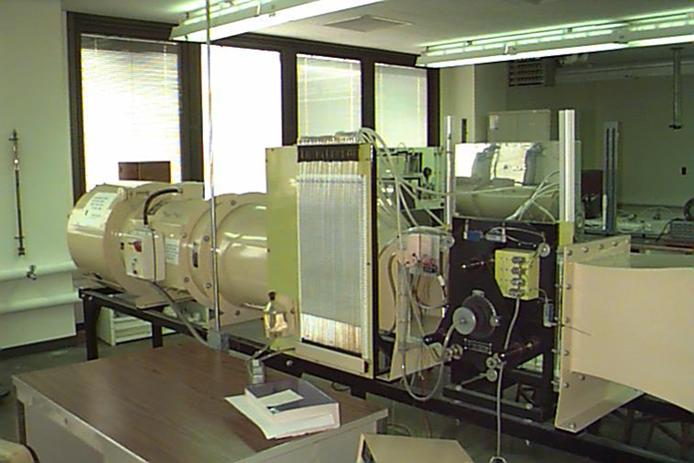

Figure 1

Figure 2

# Procedure

The procedure for this experiment begins with recording ambient temperature and pressure. Unlock the force balance so it can read data. Set the wind tunnel to the desired speed and zero the air foil angle of attack by finding where the lift force equals roughly zero. Record the lift and drag forces 20 times at 2 second intervals using the LabView software. Record the heights for each of the 24 manometers. Repeat for each angle of attack, ranging from 2 to 24 degrees. Once all data is collected for the first speed setting, repeat all steps for a slower speed setting.

The LabView data can then be exported and combined with external recordings to perform analysis on the experiment.

# Theory

The force acting on an airfoil is broken into two component forces: the lift force and drag force. The lift force, or F_L, is perpendicular to the fluid flow vector. Drag forces, or F_D, are parallel to the flow vectors. It is typical to express these forces as dimensionless values called coefficients of lift and drag, or C_L and C_D. The equation for these coefficients are:

Equation 1

Equation 2

In which F_L and F_D are lift and drag forces, ρ is the density of air, A is the characteristic area of the airfoil, and V is the velocity of air. Furthermore, the characteristic area for an air foil is defined by , where b and c are the span and chord length of the foil. Air velocity is obtained through a relationships of pressures as shown below.

The total pressure is defined as the sum of static and dynamic pressures as seen in Equation 3. For gauge pressures, this is zero.

Equation 3

Dynamic pressure is related to velocity and fluid density as governed by fluid mechanics:

Equation 4

To solve for free velocity, the dynamic pressure can be used as a function of manometer readings found during the experiment. The dynamic pressure is related to manometer height as seen in Equation 5, where is the density of air, g is the gravitational constant, and h is the manometer height.

Equation 5

# Data Analysis

Figure 3: Pressure Distribution at 0 Deg

Figure 4: Pressure Distribution at 2 Deg

Figure 5: Pressure Distribution at 4 Deg

Figure 6: Pressure Distribution at 6 Deg

Figure 7: Pressure Distribution at 8 Deg

Figure 8: Pressure Distribution at 10 Deg

Figure 9: Pressure Distribution at 12 Deg

Figure 10: Pressure Distribution at 14 Deg

Figure 11: Pressure Distribution at 16 Deg

Figure 12: Pressure Distribution at 18 Deg

Figure 13: Pressure Distribution at 20 Deg

Figure 14: Plot of Lift & Drag Coefficients

Figure 15: Plot of Lift/Drag Ratio

# Discussion

1. How does the lift coefficient vary with angle of attack?

As seen in Figure 14, the lift coefficient increases *almost* linearly with angle of attack. At the higher angle of attack, this trend begins to fall off. At an angle of zero, there is almost no lift. This is largely due to their being a small pressure difference between the top and bottom surface of the airfoil, as seen in Figure 3. As the angle is increased, this pressure difference also increases, creating an increase in lift.

1. How does the drag coefficient vary with angle of attack?

As seen in Figure 14, the drag coefficient increases gradually with angle of attack; at a slower rate than lift coefficient. At an angle of zero, there is some drag due to the body of the airfoil still impeding airflow. As the angle increases, the frontward area of the foil increases which impedes flow. The flow of air on the trailing edge of the foil also influences the drag as turbulence increases.

1. Determine the ratio of the lift and drag coefficients (CL/Cd) for the various angles of attack and compare it to published data for a NACA 0012 airfoil (airfoiltools.com)

Data is provided for a NACA 0012 airfoil from airfoiltools.com. Under similar flow conditions to the experiment, the lift/drag ratio can be seen in Figure 16. It can be seen that the values derived from the experiment are within proximity to accepted values. For the NACA 0012 airfoil, the maximum ratio is roughly 25 at ~6 degrees (BELL 540 AIRFOIL (MODIFIED NACA 0012) (b540ols-il), n.d.). The experimental value reaches a value of 30 around 5-6 degrees, as well. Both correlations see the ratio of drag to lift decrease significantly after 10 degrees.

Figure 16: Plot of Lift/Drag Coefficient for NACA 0012 Airfoil

1. Compare the lift coefficient to the drag coefficient.

As seen in Figure 14, both lift and drag increases as the angle of attack increases. However, it can also be seen that the lift coefficient increases at a faster rate than that of drag. The maximum coefficient of lift is just over 1 and is achieved at the maximum angle of 20 degrees. The coefficient of drag does not increase significantly until roughly 8 degrees and maxes out with a value of 0.4 at 20 degrees.

1. How does speed affect the lift and drag coefficients?

As seen in Equation 1 and Equation 2, the air velocity is inversely related to the coefficients of lift and drag. When the velocity increases, the denominator of each equation increases quadratically, which decreases the coefficient substantially.

1. Compare the pressure distribution of the airfoil for low and high speeds.

At both low and high speeds, it can be seen that the pressure is larger on the bottom of the airfoil than on the top. This observation describes a low pressure zone above the airfoil, which generates lift. As the angle of attack increases the pressure distribution along the length of the foil changes. At relatively low angles, such as seen in Figure 4, the pressure is mostly the same along the length of the foil after the leading edge. As the angle of the attack increases, the delta between top and bottom pressure begins to grow further down the airfoil body. Especially at the leading edge, there is a great difference between high and low speed runs; where the high speed air created larger difference in pressure between top and bottom surface.

1. Determine your stall angle.

According to the graphs above, the stall angle seems to be around 16 degrees for both high and low air velocity. This can be determined by noticing that the lift coefficients between to stop increasing or even decreasing. Around this same time, the drag coefficients are rising at a greater rate. Increasing angle of attack beyond this point creates negative consequences on the effectiveness of the airfoil, as the drag forces outweigh the benefit of lift.

# References

*BELL 540 AIRFOIL (MODIFIED NACA 0012) (b540ols-il)*. (n.d.). Retrieved from airfoiltools.com: http://airfoiltools.com/airfoil/details?airfoil=b540ols-il

# Appendix

Raw wind tunnel data - windtunneldata.xlsx